# EXPLORATORY DATA ANALYSIS FOR LOAN DEFAULT IN BANK PROJECT

#BY AGE CHECKING THE REPAYMENT AVERAGE

plt.figure(figsize=(15,6))

sns.barplot(x='age', y='repayment_status', data=loan_data, color='skyblue')

plt.title('Average Repayment Status by Age', fontsize=16)

plt.xlabel('Age', fontsize=14)

plt.ylabel('Average Repayment Status', fontsize=14)

plt.show()

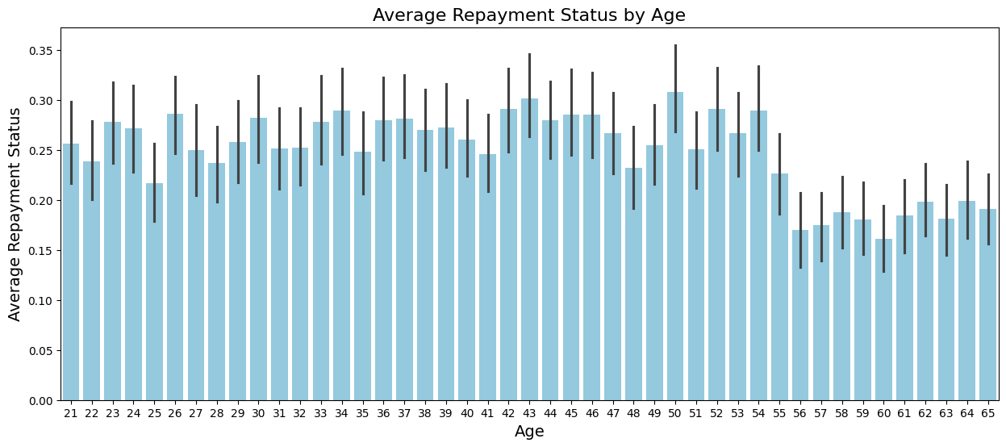

#DISPLAY THE TOP 10 HIGH LOAN CUSTOMER

top_10_loan_data = loan_data[['name', 'loan_amount', 'repayment_status']].sort_values(by='loan_amount', ascending=False).head(10)

plt.figure(figsize=(25, 6))

sns.barplot(x='name', y='loan_amount', hue='repayment_status', data=top_10_loan_data, palette='viridis')

plt.title('Top 10 Customers with the Highest Loan Amounts', fontsize=16)

plt.xlabel('Customer Name', fontsize=14)

plt.ylabel('Loan Amount', fontsize=14)

plt.xticks(rotation=45)

plt.show()

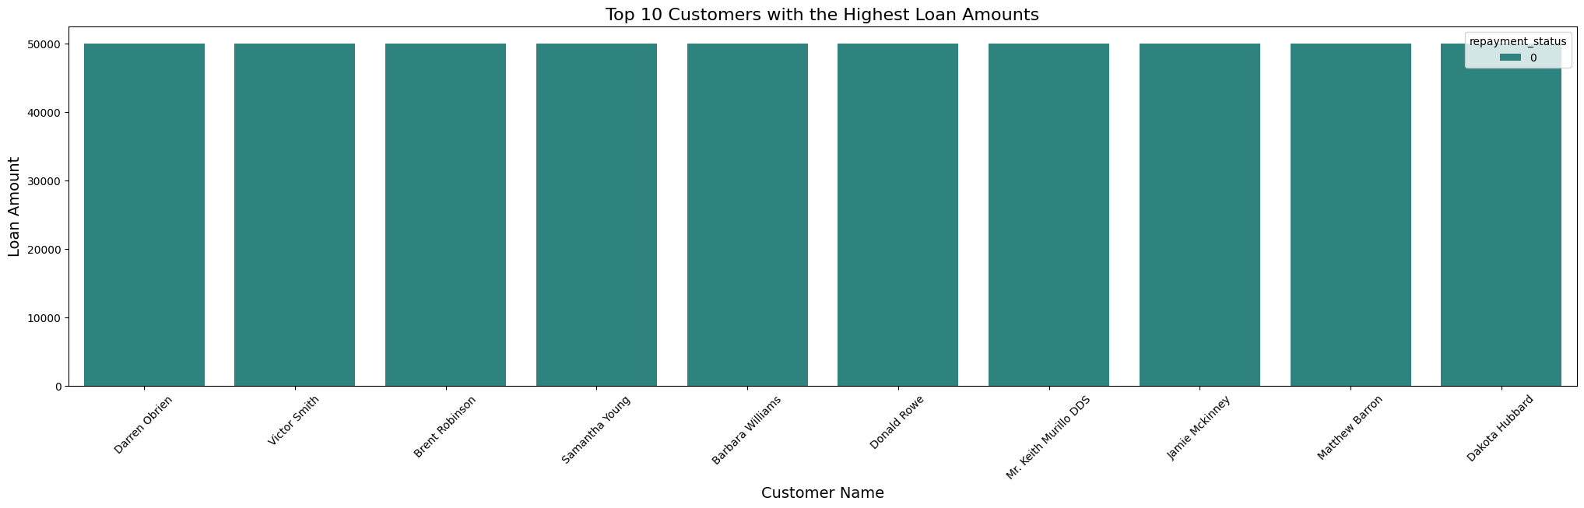

#TOP 10 HIGH INCOME CUSTOMERS WITH REPAYMENT STATUS

top_10_loan_data = loan_data[['name', 'income', 'repayment_status']].sort_values(by='income', ascending=False).head(10)

plt.figure(figsize=(25, 6))

sns.barplot(x='name', y='income', hue='repayment_status', data=top_10_loan_data, palette='magma')

plt.title('Top 10 High Income Customers with Repayment Status', fontsize=16)

plt.xlabel('Customer Name', fontsize=14)

plt.ylabel('Income', fontsize=14)

plt.xticks(rotation=45)

plt.show()

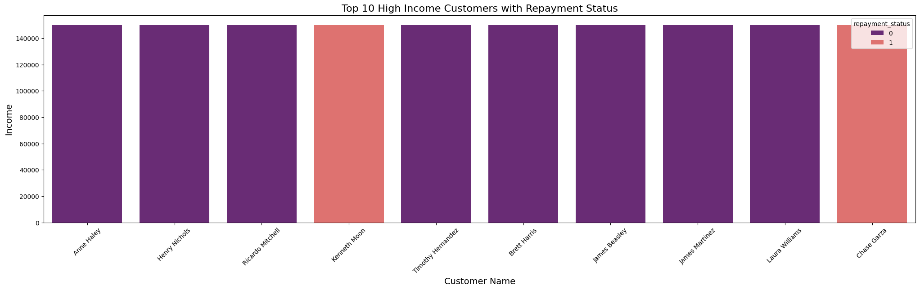

#NO OF CUSTOMER COLLECTED LOAN BY AGE WISE

plt.figure(figsize=(13,6))

sns.countplot(x="age", data=loan_data, palette='coolwarm')

plt.title('Number of Customers for Each Age', fontsize=16)

plt.xlabel('Age', fontsize=14)

plt.ylabel('Number of Customers', fontsize=14)

plt.show()

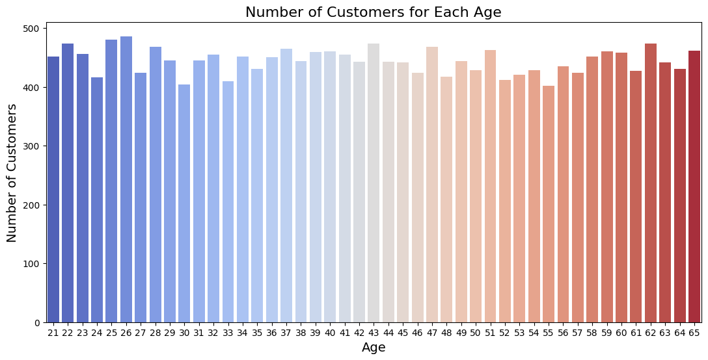

#CHECK THE CORRELATION FOR NUMERIC COLUMNS

correlation_matrix = loan_data[['age', 'income', 'credit_score', 'loan_term', 'loan_amount', 'monthly_installment', 'interest_rate']].corr()

plt.figure(figsize=(10, 8))

sns.heatmap(correlation_matrix, annot=True, cmap='coolwarm', fmt='.2f')

plt.title('Correlation Matrix', fontsize=16)

plt.show()

